Examining the Extent to Which Earnings Announcements Impact the Stock Prices of Fortune 500 Companies
Aryan Gupta
Jonathan Frishman
May 1, 2024
Word Count: 4994

Abstract
Earnings announcements are a major contributing factor to the fluctuations of stock prices especially in the case of Fortune 500 companies and Magnificent 7 companies. The findings from pre-existing studies studied the influence of earnings for individual companies, and not for companies with a large market cap and the best ones in the nation, thus as a result this study will seek to analyze the influence of earnings announcements, specifically the diluted EPS surprise aspect of earnings on the stock prices of Fortune 500 companies.
To assess the earnings influence on companies, data was compiled from 124 of 500 Fortune 500 companies with the use of the stocks app, and descriptive statistics were calculated upon this data such as the correlation coefficient and standard deviation. As a result, it was concluded that there is an influence from earnings on the stock price of Fortune 500 companies; however, there is extreme volatility present in the stock prices for these companies. A company's earnings can vary by a drastic range despite positive or negative earnings reports, showing that the correlation present between the earnings for Fortune 500 companies and stock prices for these companies has significant room for volatility.

Examining the Extent to Which Earnings Announcements Impact the Stock Prices of Fortune 500 Companies
The context of this study revolves around the focus on the stock market, a place where investors can invest in a company's stock and make a taxable income off of doing so. Earnings are pieces of information released by companies every quarter of the year, showing the business's profit, and loss margins. Typically, a company releases earnings in January, April, July, and October. Stocks with large market liquidity and a large amount of day-to-day trading, such as Fortune 500 Companies, tend not to be greatly impacted by earning announcements in the short run, but this study will seek to combat this misconception. Fortune 500 companies are defined for this study as the top 500 companies in the year 2023 as a result of the data being collected during this time frame.
No pre-existing studies have been conducted on the earnings announcements of Fortune 500 companies. Studies have primarily focused on the earnings impacts on singular stocks as depicted by the initial research which revolved around the implications of surrounding factors on a stock price. The initial exploration of the research was surrounded by the implications of external factors on a stock price and the inability of people to see the influence of earnings. As a result, people are unable to predict how high a stock rate will go up, and what factors can contribute to good earnings announcements that cause the rate of a stock to go up. Through data methods such as predicting the standard deviation of the data and finding the descriptive statistics of the data, this study will accurately predict how high on average a stock price will go up following the Fortune 500 earnings announcements of companies and whether or not there is a correlation between a stock price and its diluted EPS surprise as found in its earnings report. In turn, investors will be able to accurately predict the day-to-day increases in the stock market. Amidst the current market situation, analysts give findings on specific stock prices and their estimated predictions. While the importance of these analysts should not be overlooked, analysts typically give predictions solely based on the success of companies while not looking at the earnings announcements themselves thus signifying the importance of the method and the purpose of its creation.
Literature Review
Influential Results: Earnings Role on Profit Margins of Companies
A recent study done by Abdullahi Mohamed Nur, the State Minister for Finance of Somalia, has found that there is a general correlation between good news and an increased stock price following the earnings announcements (Nur, 2021). In concurrence, an older study done by Mujtaba Mian, a Professor of Finance at Zayed University, and Srinivasan Sankaraguruswamy, a professor at the National University of Singapore, has found that market sentiment or good news essentially has an influential result on stock prices (Mian & Sankaraguruswamy, 2012). As shown in the studies, there are prevalent implications of earning announcements and market sentiment on the stock market. Typically, good news causes a stock price to increase as a result of higher profit-to-loss margins which is a result of increased investment as a result of more revenues that a company has produced within the given quarter of the year. Better revenues and profits that a company produces cause investors to tend to invest in a stock to see returns off of doing so. There has been historical reassurance for this claim as well, a paper written by Matt Nesvisky, a Professor in the English department at Kutztown University of Pennsylvania, shows how the stock prices of companies in 1972 moved up nearing earnings announcements (Nesvisky, 2008). These companies had extremely great revenues and profits especially due to the end of the Great Depression and amidst the Cold War in which the economy of the US significantly benefited as the US economy is primarily run off of war. The historical market changes can be used to assess the current-day predictability of a stock price.
Assessing the PEAD
The Post Earnings Announcements Drift (PEAD) defined by Josef Fink, from the Department of Banking and Finance at the University of Graz, is the “drift of a firm’s stock price in the direction of the firm’s earnings surprise for an extended period of time” (Fink, 2021). Causes of PEAD have been widely studied, with an academic paper written by Benjamin C. Ayers, a Dean of the University of Georgia Terry College of Business, showing that PEAD occurs as a result of a group of smaller and larger investors' continual investment in a company after its earnings have been released (Ayers et al., 2011). In concurrence, a study done by Hirshleifer, a Professor of Finance at Marshall School of Business, disproved the idea that individual investors cause the PAED (Hirshleifer et al., 2008). The PEAD is widely influenced by a group of investors and not by individual investors depicting the profound influence of the PEAD on a given stock. The PEAD has been shown to contribute to abnormal stock returns following earnings releases. Analyzing the PEAD covers the idea of how the impact of earnings can persist over time and can be used to gain larger profits for long-term and day traders. The two graphs below found in Jonathan N. Katz, Mathew D. McCubbins, and Jeff L. McMullin’s academic paper, all professors of Social Sciences, depict the significance of the study and analysis of the PEAD to the extent done in this study. As depicted by the graphs, the PEAD had drastic fluctuations in the weeks after earnings reports regardless of whether the earnings themselves were positive or negative. In weeks 11-13, there was an extremely high abnormal BHAR (buy and hold return) value showing that many bought a stock price in the periods following an earnings announcement to a great extent signifying the influence that the PEAD itself provides (Katz et al., 2018).
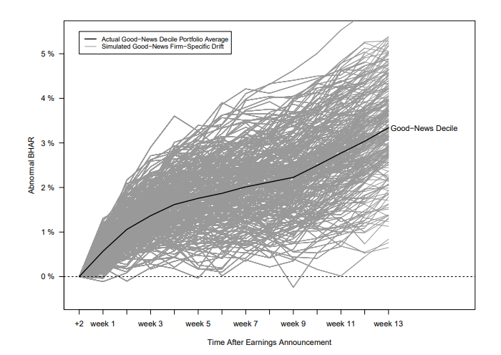
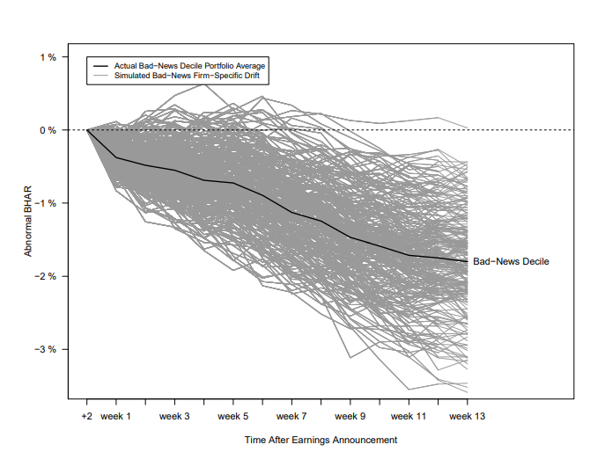
Influential Factors on a Stock Price
The impact of analysts can have a drastic effect on the stock price following an earnings announcement. In a research study done by Ciciretti, an Associate Professor of Economic Policy at the University of Rome, it was found that when an analyst tends to favor a company, the stock’s liquidity tends to increase in the days near earning announcements. On the other hand, when analysts have less hope for a stock, fewer people buy it. The only problem with relying on analysts’ reports is that typically, an analyst's report is flawed giving unrealistic expectations for the success of a stock shortly (Ciciretti et al., 2009). It is also found, by William H. Beaver and Maureen McNichols, from the Stanford Graduate School of Business, and Zach Z. Wang, from the Gies College of Business, that increased information disclosure and analysts' reports concur to cause an increase in the investor response to an earnings announcement (Beaver & McNichols, 2020). This goes to show that when there is more communication going around over the price of a stock, investors are more likely to invest in that stock as a result of FOMO (fear of missing out). A bullish market, or successful market, as compared to a bearish market, or one in which the share prices are dropping, plays a key role in investor attitude towards an earnings announcement. Other factors such as stock market crashes and global factors such as the Ukrainian-Russian war play an important part in the stock market. This war ruined the oil and gas companies causing many stocks of these companies to fall and declare bankruptcy; however, on the other hand, companies such as Aerojet Rocketdyne, a weapons and missile producer that supplied a large amount of weapons in the war effort, went up in the time of the war.
In the past, the stock market has also crashed various times, especially during the COVID period when earnings were at an all-time low. In illustrating the significance that COVID had on the stock market it was found in an academic paper written by Teresia Angelia Kusumahadi and Fikri C Permana, both from the University of Indonesia, in the last week of February 2020, during peak COVID times, the S&P 500 crash caused a capital loss of over five trillion dollars (Kusumahadi & Permana, 2021). Finally, a company's profit-earnings ratio (PE ratio) can play an influential part in a stock as well. When a company has a high PE ratio they are typically overvalued, and when they have a low one they are undervalued. The PE ratio can be found by dividing the share price by the earnings per share. Overall to make higher profit margins on stocks the question is to what extent do stock prices for Fortune 500 companies fluctuate due to their earnings announcements and whether earnings announcements, specifically the diluted EPS percent surprise, impact the stock prices of companies, needs to be pursued. The hypothesized value that will be assumed in the context of this study will be a median fluctuation of the stock price by a value of 5% for the given Fortune 500 companies as a byproduct of its earnings reports.

Research Design
The research design that will be conducted is an ex post facto research study as the process in which data will be collected is through observing data directly from the stock market and earnings announcements and finding the correlations between the data. An ex post facto research design is based on collecting statistics on data that has already been published deeming its translation to “from a thing done afterward” in Latin. The purpose of the study is to find the relationships between the loss and gain per share as compared to the increase in the stock price in the 24-hour post-earnings releases. This study fits in with the respective zone of research as it depicts the impacts of earning announcements on share prices which many people have done in the stock market field; however, the specific gap in the study pertains to the specificity of the research question on focusing directly on Fortune 500 companies and the diluted EPS percent surprise values.
In the context of this method, the dependent variable will be the stock price change as estimated on the Stocks app not including the after hours of the market. The independent variable on the other hand will be the diluted EPS percent change of the companies per quarter. Data will also be collected upon quantitative findings rather than qualitative allowing for descriptive statistics and more to be calculated on the results.
Methods
Stock price fluctuations will be collected during the market day, between 8:30 a.m. to 3:00 p.m. for the Central Time Zone which is a form of secondhand quantitative data. Data will also be collected on the diluted EPS percent surprise for a company to find the correlation between earnings reports and stock price changes. The stock price change will be collected a month after the company’s earnings report as well to symbolize the correlation that earnings specifically have on a stock price rather than the market sentiment during that time. This data will serve as a constant to be solely inflicted by market sentiment and the PEAD as discussed above.
Methods such as taking the descriptive statistics of the quantitative data will be employed. A similar approach was taken in Rocco Ciciretti’s academic paper in which Cicirreti listed the standard of deviation and the mean of the data of analysts' expectations towards earnings announcements on individual stocks to depict the correlations between the given data (Ciciretti et al., 2009). By taking into account the mean, the standard of deviation can be calculated to see what the lower end of the spectrum for stock earnings tends to be as compared to the higher end of the spectrum. The mean will give investors a good idea of whether a stock price tends to typically go down or up following the earnings releases and by what estimate it does for Fortune 500 companies, thereby directly answering the research question that was sought to solve.
Calculating the median has the purpose of finding the percent that a stock price will most likely fluctuate following the collection of all of the data. The median will serve the same purpose as the mean, but rather be employed as a resistant method of calculation, or a method not affected drastically by outliers and skews in the data. Using the median of the data a boxplot for the data will be generated with the 5-number summary of the IQR, Q1, Q3, median, and the maximum and minimum of the day of earnings announcement fluctuations and the month after as well. By creating a boxplot to display the data collected, investors will have the ability to see the typical fluctuation of a stock price following the earnings release. To examine the extent to which the losses and gains on a stock impact the stock price, the correlation coefficient of the data in the market hours will be calculated using a least squares regression line found on a scatterplot employing the formula ŷ= ax+b. A correlation coefficient closer to 1 will show that the data is heavily correlated, and one closer to 0 will show a large discrepancy between earnings and gain and losses per share for a market day.
Data will be collected through the usage of the globally accessible stocks app which lists earnings announcement data and stock price changes for all global companies with pinpoint accuracy. Online websites will be used in coordination to find which companies are reporting their earnings on what given days and whether or not these companies are classified as the 2023 Fortune 500 companies.
Procedure
Initially, the stock price fluctuations on the day of the earnings announcements will be taken into a spreadsheet. The diluted EPS percent surprise will be collected by subtracting net income from preferred dividends, all divided by the average number of outstanding common shares. The percent change from the previous earnings announcement releases compared to the October and November or current earnings releases will be presented as the independent variable. This independent variable will depict the results of the earnings announcements which will then be compared to the percent change in stock prices to see if data collected in a company earnings release correlates with the percent change of the stock price on the day of earnings releases. Exactly a month after a company has released its earnings announcement, data will be collected again on the exact stock price on that day to emphasize the implications of earnings announcements. The month after data will serve to be a constant to assess whether market factors are causing the stock prices to fluctuate or if it is all due to the earnings releases.
With the stock price fluctuations on the day of earnings announcements and the month after earnings announcements, the 5-number summary, mean and standard of deviation will be calculated. Two boxplots will be constructed both to depict the stock price changes the month after and the day of earnings announcements. The standard deviation curve for both pieces of data will also be depicted in the overall results, which were all inspired by the main cornerstone source used in this academic paper written by William H. Beaver and Maureen McNichols (Beaver et al., 2020). Finally, as the last step of the process, the correlation coefficient of the data will be calculated with the independent and dependent variables.

Results
Correlation Between Earnings and Price Changes
Data was collected from 124 Fortune 500 companies upon their 3rd quarter earnings reports. The stock price percentage changes on the day of the earnings release were found for each company excluding after hours in which the market is closed, but the stock price still fluctuates. This data was then compiled and related to the key factor in earnings reports, diluted EPS percent surprise. The EPS does not have a definite range of what is good or bad, rather the Diluted EPS surprise is the factor taken into account in an earnings announcement. The surprise is the percentage difference between the estimated value of the EPS and the EPS reported in an earnings announcement. As seen in Figure 1, with the x-axis being the Diluted EPS surprise and the y-axis being the earnings day of stock price change, there is a positive correlation present between the Diluted EPS and the stock price percent. On average, the lower the diluted EPS surprise was the greater the stock price fell on the given day, and the higher it was, the more the stock price would increase on that given day. The top fluctuations were at a 6.17% Diluted EPS surprise and a 9.69% stock price change, alongside the other end with a -14.13% Diluted EPS surprise and a -12.38% change in the stock price.
Figure 1: Relationship between Diluted EPS Surprise and Day of Earnings Stock Price Fluctuations
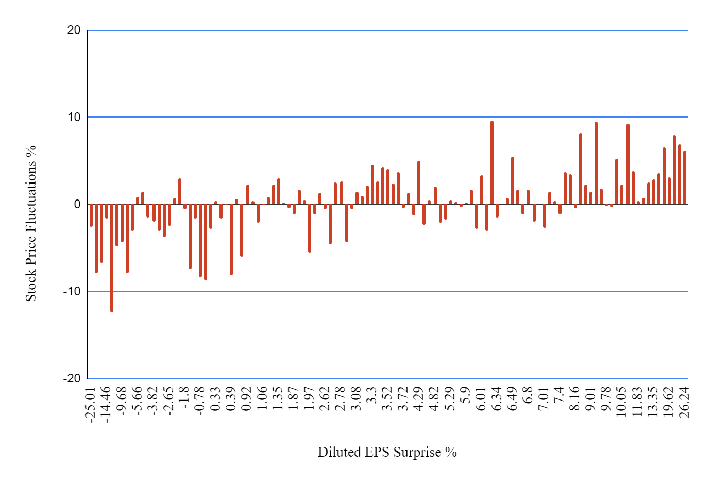
In assessing Figure 1 the correlation coefficient between the 2 variables presented is 0.6164 which shows a moderate positive correlation between the two variables. As the correlation coefficient is positive, the data is increasing moderately. The closer the correlation is to 1 or -1 the more closely the data is connected and can be used as a contributing factor to calculate the other. The maximum the diluted EPS rises to is 26.24% and the minimum is -25.01%. At both of those values, the stock price changes are a high positive or a high negative respectively.
Stock Price Fluctuation Day Of and Month After Earnings
Figure 2 depicts the median, maximum, minimum, Quartile 1, and Quartile 3 of the day of stock price percent changes. The maximum of the data is 9.69%, the minimum is -12.38%, Q1 is -1.645, Q3 is 2.37, and the median of the data is 0.41%. The mean was 0.41% depicting an increase in the stock price as a result of earnings releases. The data tends to fluctuate by a large percentage depicting the large changes that earnings produce on the price of a stock. This is further illustrated by the standard deviation of 3.738 from the mean of 0.222.
Figure 2: Day of Earnings Stock Price Fluctuation
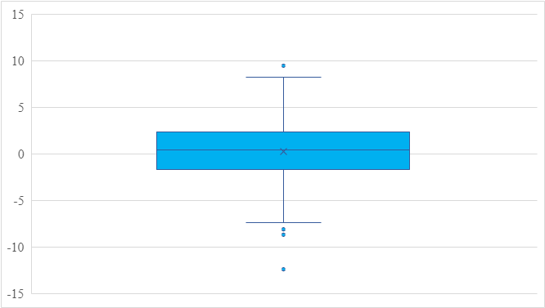
Figure 3 shows the stock price fluctuations of the given company 1 month after its earnings releases to control for external global factors such as wars; however, eliminating the PEAD has an influence on the days after the release of an earnings report for a company. The maximum of the data is 8.87%, the minimum is -5.12%, Q1 is -0.13, Q3 is 0.865, and the median of the data is 0.3. There is not as much of a significant spread in the data for a month later with a standard deviation of 1.294 and a mean of 0.471. The mean is greater for this set of data, but the standard deviation is less with the mean close to 0 and the median as well.
Figure 3: Month After Stock Price Fluctuations
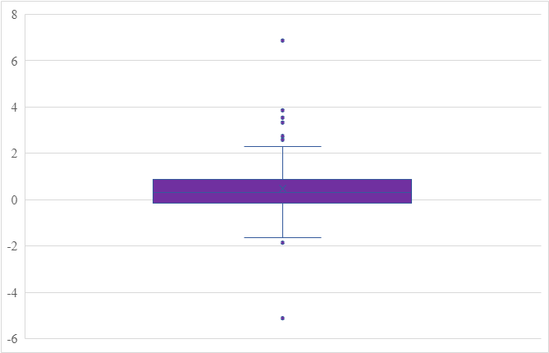
Findings
Correlation Between Earnings and Price Changes
Data was collected from 124 Fortune 500 companies upon their 3rd quarter earnings reports depicting a correlation between earnings on the day of the earnings report and the Diluted EPS percent change. This is illustrated by the correlation coefficient of 0.61, indicating a moderate positive relationship between the data. When the Diluted EPS has a large change, there is also a synonymous large change in the earnings.
In directly answering the research question there is a correlation between the earnings announcements and the stock price changes as depicted in Figure 1. The correlation allows investors to invest in their stocks with relative knowledge that the stock price will go up after releasing a company's Diluted EPS surprise. Despite this, this moderate correlation coefficient shows room for volatility in the stock price fluctuation. This volatility synonymously stems from a variety of factors that may influence a stock price such as the trading volume of a stock and more as depicted by Bartov, a Professor of Accounting at New York University's School of Business, in his research paper (Bartov et al., 2000). In conjunction, with a study done by Wonseok Choi and his team, a finance major from The University of Texas Rio Grande Valley, nearing the days of investments, sellers seem to sell their stock regardless of the earnings on a day as a result of the fear of bad earnings (Choi et al., 2010). Contributing factors like this can cause the stock price to fall even despite good earnings illustrating only the moderate positive correlation coefficient present in the data rather than a strong correlation. Despite this setback, it can be concluded that the stock price of a stock does for the most part fluctuate relative to its diluted EPS surprise percent with the maximum and the minimum in Figure 1 also working to support this conclusion. These findings concur with the findings presented in Turan, Tehranian, and Bali’s academic papers, professors from the University of Georgetown, Boston University, and Boston University respectively, in which there is a clear positive correlation present between the stock price percent changes and a company's earnings announcement, in this case directly pertaining to Fortune 500 companies. Bali discusses the implications of market estimations as compared to the earnings of a stock which is directly what is done with the usage of the EPS surprise percentage comparing the analyst's diluted EPS of a stock with the real diluted EPS of the stock (Bali et al., 2008).
Percent Fluctuation of Stock Prices
While a drastic positive relationship was not inherent within the data, the mean and median can be contributing factors to be used for future references. The median of the data on the day of the earnings release was 0.41. This shows that the data fluctuates in the positive direction on average for the majority of the data following their earnings announcements. The median of the data depicts a low growth of a stock price; however, as depicted by the maximum of 9.69% and the minimum of -12.38%, there is a large variance in the extremities to which the stock price fluctuates following their earnings releases. This is further depicted by the standard deviation of the data being 3.738. This standard deviation from the mean shows a large variance and spread within the data.
On the other hand, a month after a company released its earnings reports, the data had a similar median value of 0.3, but with a lower maximum and a higher minimum of 8.87% and -5.12% respectively. As depicted by the maximum and minimum of this data, the earnings of a company a month after the release of their earnings reports have lower extremities than do the earnings of companies on the day after the earnings reports illustrating the lack of significance in the month after stock fluctuations. The standard deviation of 1.294 and the mean of 0.471 show that there is little variance in the data with the majority of the data within a standard deviation away from the mean. Most of this variance is attributed to market factors such as market sentiment and investor response.
In comparing the month after and day-of-earnings responses, the month after earnings responses situated less drastic stock price fluctuations on a given day due to no influence from an earnings announcement. The day of earnings release; however, has drastic stock price fluctuations away from the mean as depicted by the standard deviation of 3.738 compared to the minuscule standard deviation of 1.294 for the month after earnings reports. This comparison depicts the influence that an earning announcement has on a stock price. Stock prices tend to fluctuate close to their earnings showing their influence as compared to a month later where, as a result of no earnings, a stock price does not fluctuate as much as it would on the day of its earnings release.
In referring back to the hypothesis, the initial hypothesized value is not met as a result of the relatively small median value of 0.41% for the day of earnings reports. However, despite the expected values not meeting the hypothesized values, there is significance present in the standard deviations between the day of earnings reports as compared to the month after earnings reports. This signifies the influence that earnings have on the stock price fluctuations as compared to solely external market influence in the month after graph.
Limitations
The study had drastic limitations laid upon it; especially protuberant was the usage of secondhand data collected from the stocks app in the collection of this data. The analyst's diluted EPS surprise also comes from second-hand not as reliable data. William H. Beaver and Maureen McNichols, graduates of the Stanford Graduate School of Business, both illustrate the importance of an analyst's response on contributing towards a stock price (Beaver & McNichols, 2020). The analyst's report was an essential contributing factor to an earnings announcement and was collected through secondhand reports, but regardless was a crucial aspect of the paper. Alongside the collection of second hand data, the data also was inflicted by a plethora of surrounding factors such as market unsettlement and an economic downturn. These contributing factors caused a large number of stock prices to fall regardless of whether their diluted EPS surprise was positive or negative. Pavel Savor, a Professor of Finance at DePaul University, and Mungo Wilson, an Associate Professor of Finance at the University of Oxford, investigated in their academic paper the implications of time of earnings releases upon a stock price further illustrating the variety of causes for a stock to potentially rise and fall (Savor & Wilson, 2016). This influential factor also contributed to the fluctuation of stock prices for these Fortune 500 companies alongside the fluctuations that occurred as a byproduct of an earnings announcement.
Implications
While the reports were from second-hand resources, the implications of the findings were drastic and illustrated a clear correlation between the earnings of a company and its stock price fluctuations. Investors can use this information to make clarified decisions on whether to buy a stock and whether or not the stock price will rise or fall. Patricia M. Dechow and Richard G. Sloan, both professors at the University of Southern California, and Jenny Zha a professor of Accounting at George Washington University, discover in an academic paper that earnings are an extremely beneficial tool for investors to use and exploit to analyze the change of a stock price and whether they will or will not make money on the day of the earnings (Dechow et al., 2014). The findings brought forward in this study correlated with the findings in this research further exemplifying the impacts of earnings on all companies alike, and the extent of their influence on specifically Fortune 500 companies. The usage of the collected data will help investors, with relative ease, invest in Fortune 500 companies with large diluted EPS percent surprises depicting its profound implications.

Future Directions
In the context of this study, the only factor used in assessing a company's earnings was its diluted EPS percent surprise, as this was one of the most influential factors in a stock price; however, for future studies, other aspects of earnings should be studied more in-depth, such as the revenue and income that a company gained in the given quarter. Secondly, as the data all came from second-hand resources alongside there being a wide array of synonymously contributing factors in an earnings announcement, a drastic direct relationship was not depicted for the case of this study, but with access to a greater array of resources, this may easily be fixed and attainable. Earnings should also be collected upon a wider range of companies, specifically 300 plus companies, to provide more accurate results alongside providing a potentially greater median for day-of-earnings reports as compared to a month after earnings reports. Data should also be collected on the estimated future diluted EPS percent changes and assess whether the results found for future estimates correlate with the findings brought forward in this study. These future findings will help further develop the claim of earnings implications of Fortune 500 companies.

Conclusion
In the entirety of the research study, there was an illustrious relationship between the earnings releases for Fortune 500 companies and the stock price fluctuations for companies on the day of earnings. The month after earnings depict that there are no apparent stock price fluctuations for earnings a month after their reports, and there is a drastic influence of stock prices on the day of earnings as compared to the month after. Earnings for these Fortune 500 companies tend to have a direct relationship with their diluted EPS surprise directly answering the research question that this study hoped to answer.
In answering the gap, Fortune 500 companies were the sole companies that were analyzed in the entirety of this research study, and the correlations between the data that were depicted applied specifically to these companies. In the long run, albeit there was not a strong positive correlation, it can be generalized for most Fortune 500 companies that earnings drastically impact stock price fluctuations. A key conclusion that should be brought forward based on the findings is that drastic earnings and extremely high earnings releases do not necessarily mean that the stock price will rise dramatically. Precautions must be taken for this study as investors may lose money as a result of misguided investments in companies. There are a multitude of other factors that play a part in a stock price fluctuation that could cause a stock price to fluctuate regardless of a good diluted EPS percent surprise, so not all investments will reap the benefits as proclaimed in this study. However despite these setbacks, in the research paper, a clear response is depicted between earnings announcements for Fortune 500 companies and their stock price fluctuations, as depicted by the correlation coefficient and the lack of variability in the month after earnings.
Word Count: 4994
References
Ayers, B. C., Li, O. Z., & Yeung, P. E. (2011). Investor Trading and the Post-Earnings-Announcement Drift. The Accounting Review, 86(2), 385–416. http://www.jstor.org/stable/29780240.
Bali, T. G., Demirtas, K. O., & Tehranian, H. (2008). Aggregate Earnings, Firm-Level Earnings, and Expected Stock Returns. The Journal of Financial and Quantitative Analysis, 43(3), 657–684. https://www.jstor.org/stable/27647366.
Bartov, E., Radhakrishnan, S., & Krinsky, I. (2000). Investor Sophistication and Patterns in Stock Returns after Earnings Announcements. The Accounting Review, 75(1), 43–63. http://www.jstor.org/stable/248632.
Beaver, W. H., McNichols, M. F., &amp; Wang, Z. Z. (2020). Increased market response to earnings announcements in the 21st century: An Empirical Investigation. Science Direct. https://doi.org/10.1016/j.jacceco.2019.101244.
Choi, W., Hoyem, K., & Kim, J.-W. (2010). Capital Gains Overhang and the Earnings Announcement Volume Premium. Financial Analysts Journal, 66(2), 40–53. http://www.jstor.org/stable/27809178.
Ciciretti, R., Dwyer, G. P., & Hasan, lftekhar. (2009). Investment Analysts’ Forecasts of Earnings. Review (00149187), 91(5), 545–567. search.ebscohost.com/login.aspx?direct=true&db=asn&AN=47272264&site=ehost-live.
Dechow, P. M., Sloan, R. G., & Zha, J. (2014). Stock Prices and Earnings: A History of Research. Annual Review of Financial Economics, 6, 343–363. http://www.jstor.org/stable/44864085.
Fink, J. (2021, March). A review of the Post-Earnings-Announcement Drift. Science Direct. https://doi.org/10.1016/j.jbef.2020.100446.
Hirshleifer, D. A., Myers, J. N., Myers, L. A., & Teoh, S. H. (2008). Do Individual Investors Cause Post-Earnings Announcement Drift? Direct Evidence from Personal Trades. The Accounting Review, 83(6), 1521–1550. http://www.jstor.org/stable/30243805.
Katz, J. N., McCubbins, M. D., & McMullin, J. L., (2018). The Post-Earnings Announcement Drift: An Anomalous Anomaly. https://jkatz.caltech.edu/documents/3960/peads.pdf.
Kusumahadi, T. A., & Permana, F. C. (2021). Impact of COVID-19 on Global Stock Market Volatility. Journal of Economic Integration, 36(1), 20–45. https://www.jstor.org/stable/26985574.
Mian, G. M., & Sankaraguruswamy, S. (2012). Investor Sentiment and Stock Market Response to Earnings News. The Accounting Review, 87(4), 1357–1384. http://www.jstor.org/stable/23246280.
Nesvisky, M. (2008, March 3). Stocks rise around earnings announcements. NBER https://www.nber.org/digest/mar08/stocks-rise-around-earnings-announcements.
Nur, A. M. (2021). Quarterly Earnings Announcement and its Impact on Corporate Financial Performance. Muhasebe Bilim Dünyası Dergisi, 23 (4) , 797-815 . https://doi.org/10.31460/mbdd.878008.
Savor, P., & Wilson, M. (2016). Earnings Announcements and Systematic Risk. The Journal of Finance, 71(1), 83–138. http://www.jstor.org/stable/43869096.

